2019
Cortes Community Forest Co-op AGM
Ground-truthing Report:
A Work in Progress

Two separate parts to long term planning:
1) Scientifically credible understanding of current forest upon which to base harvest forecasts
2) Consideration of ecological, economic, regulatory and partnership factors which are necessary to a viable and successful community forest operation

(Notes: number one is the subject of this presentation. The coop has shown a lot of interest in this through the years. Number two belongs to CFGP. It includes diverse and challenging restraints. Economic viability is essential. Our community forest area is with the traditional and unceeded territories of the Klahoose , Homalco and Tla’amin First Nations. With respect we support reconciliation and the diverse needs of our communities)

CCFC Ground-truthing:
There is a strong foundation and on-going work by CFGP.
(Notes: We aren’t inventing the wheel here. We have community generated documents, boots on the ground, MoF data)

1 Community generated documents:
A
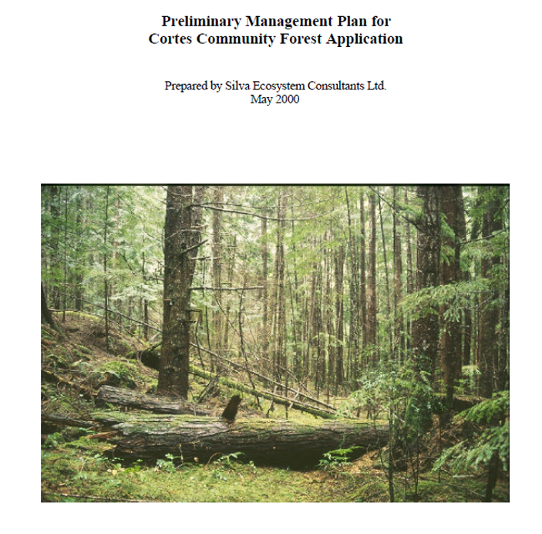
B
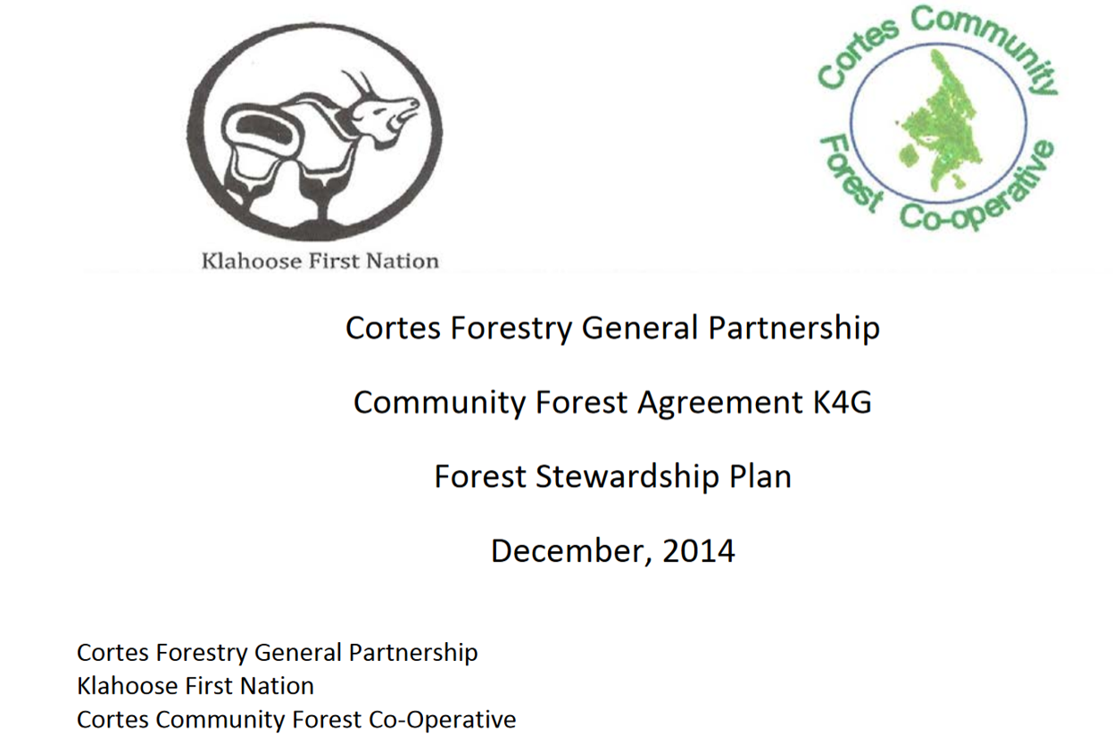
C
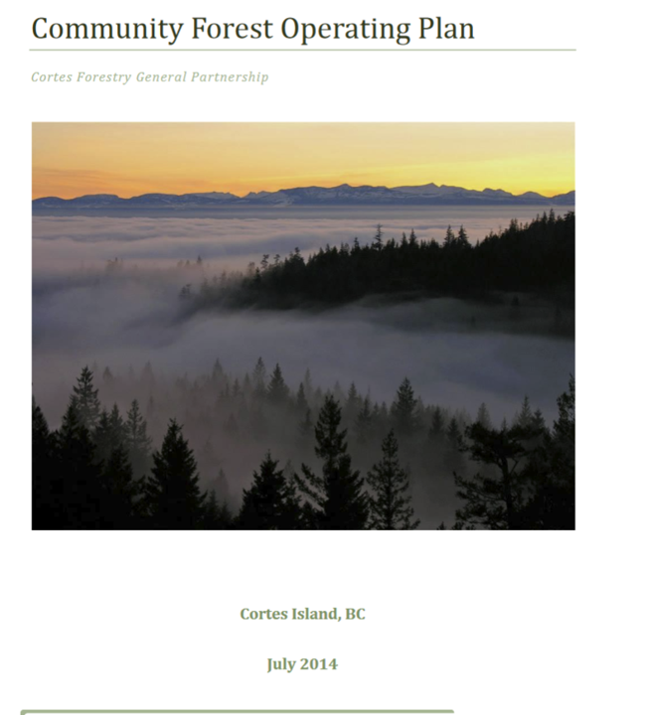

2 Boots on the ground:
Mark Lombard, Forest Manager
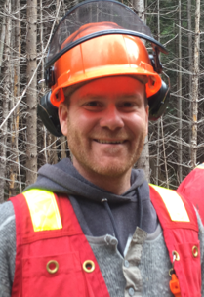
(Notes: Boots on the ground. Mark Lombard spends a huge amount of time in the community forest. His work includes analyzing the entire CF land base, planning for specific operations and returning to cut areas to learn from them. He shares his thinking freely with the community. We are incredibly lucky to have him, especially because he skillfully plays a difficult role in which he forges workable compromises with all interest groups.)

CFGP plans to establish test plots with our RPF. These will be monitored through time.

3 MoF Info
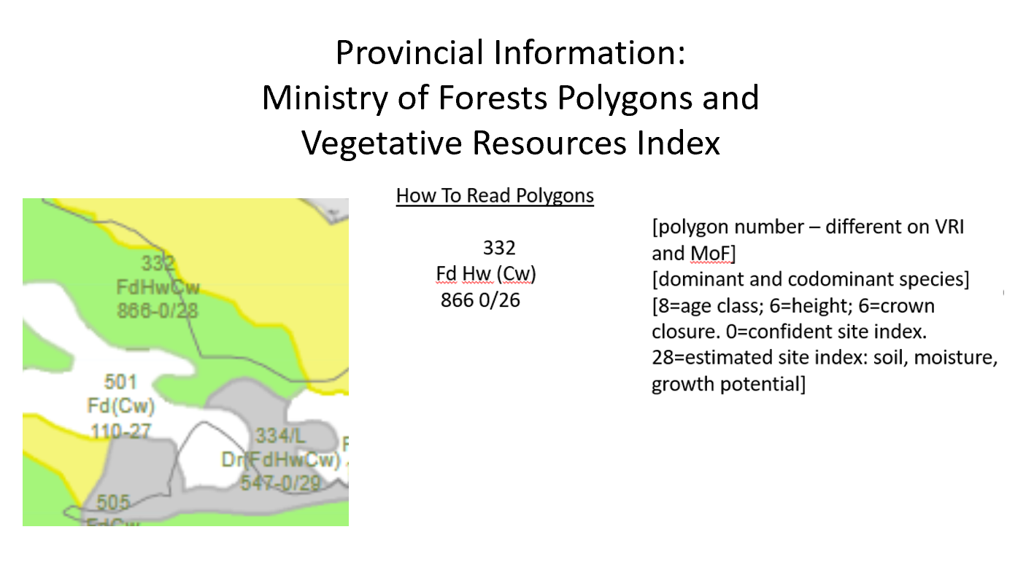
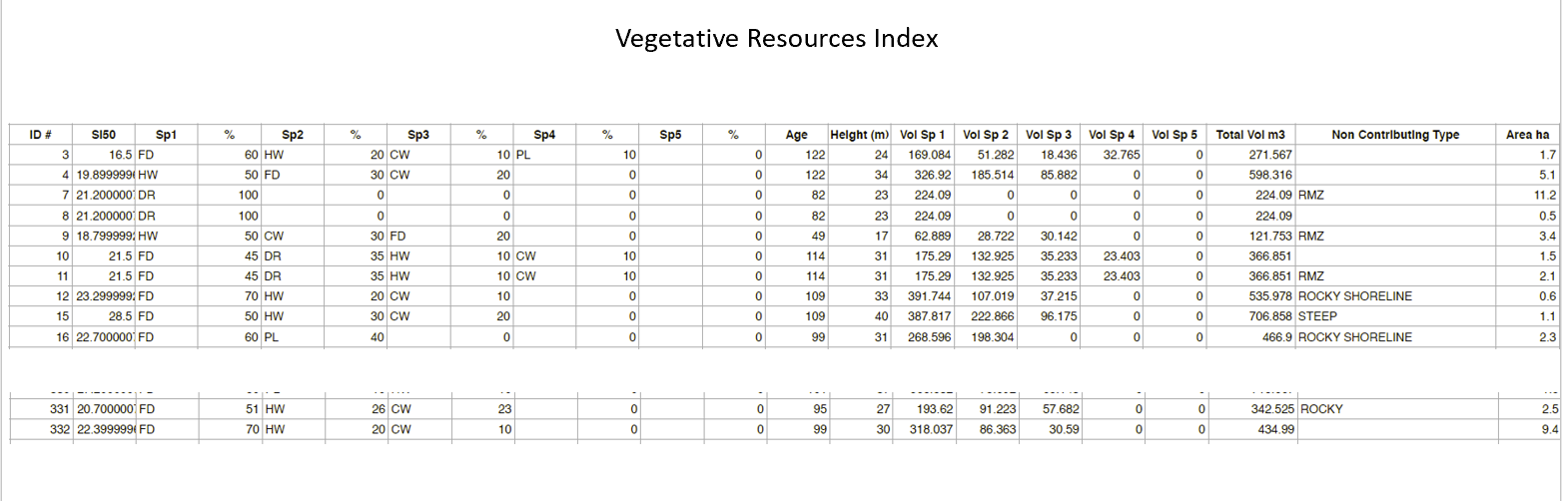
We have community generated plans, trustworthy operations staff and lots of information from MoF.
This puts us in a better position than many
community forests.
So do we need more ground-truthing?

Community Generated Plans:
- Silva Forest Foundation’s Preliminary Management Plan 2000:
    - The plan itself acknowledges that the information in it is incomplete and more ground-truthing is needed
    - The plan applies to a different (larger) land base and extrapolating its information to the CF timber harvest land base may be imprecise – we are only now reaching consensus on basic numbers
    - The plan did not analyze proposed cut rates in terms of economic viability
- The CFGP Forest Stewardship Plan primarily responds to MoF requirements.
- The CFOP is aspirational and non-technical.

2 Operational staff of the Community Forest General Partnership:
  - We currently have very trustworthy operational staff but staff can change through the years
  - Some CCFC members desire to better understand long-term consequences of decisions

3 Ministry of Forests Info
Based on aerial photos and generalized information which was gathered from other parts of the Sunshine Coast Forest District, and never ground-truthed for Cortes Island.
- The data layers don’t mesh – eg the SEI and VRI.
- Old forests aren’t fully mapped
- Rehab zones aren’t mapped – eg mistletoe infected hemlock

Community reasons for ground-truthing:
- CCFC membership asked for ground-truthing at the last AGM
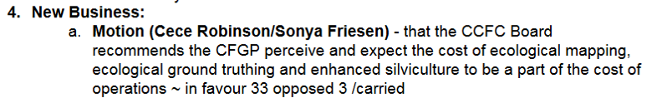
- Ground-truthing is fun and educational.

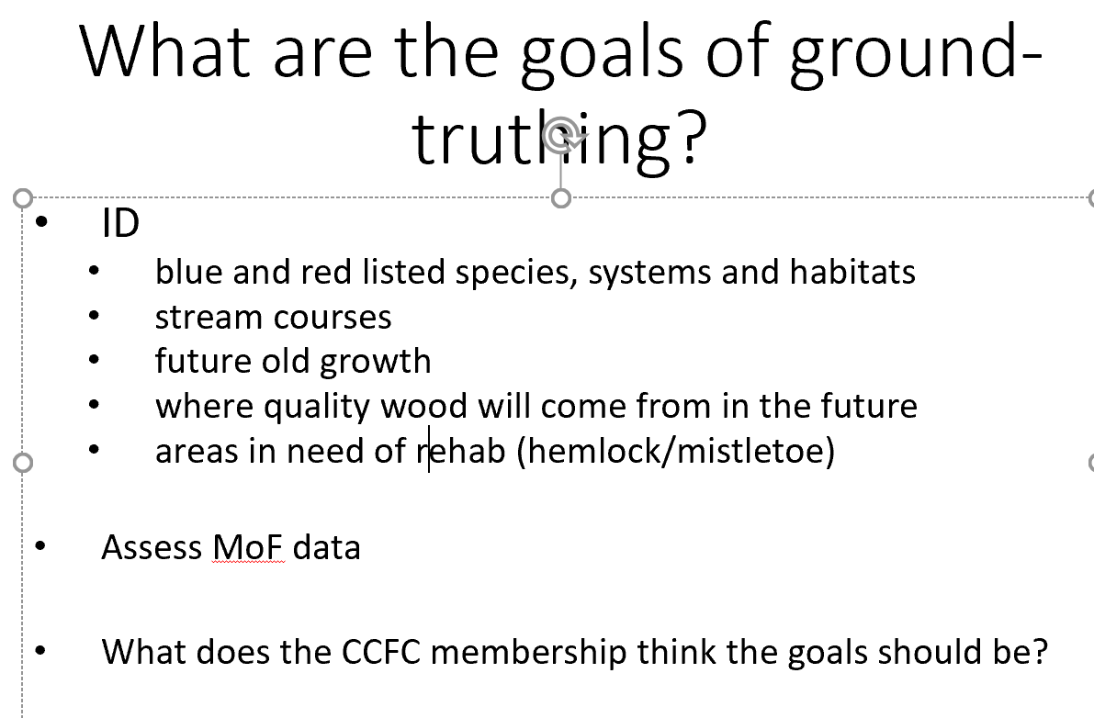

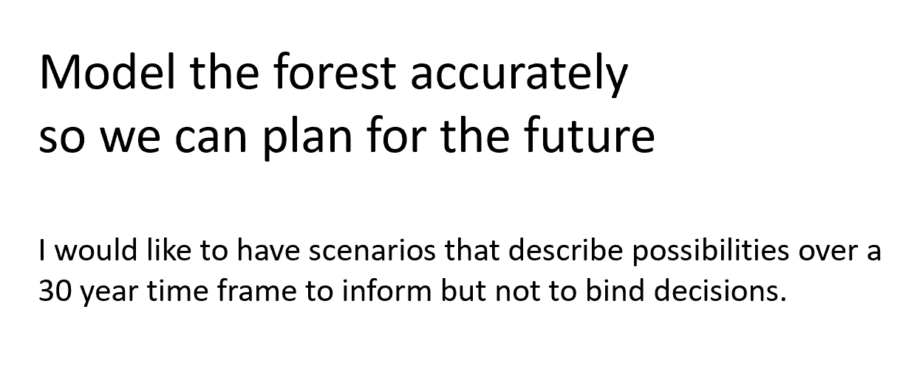
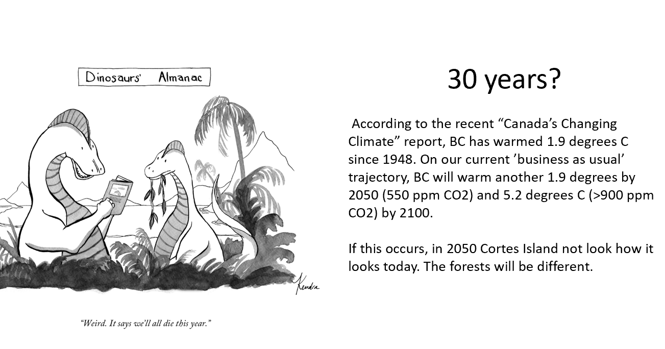
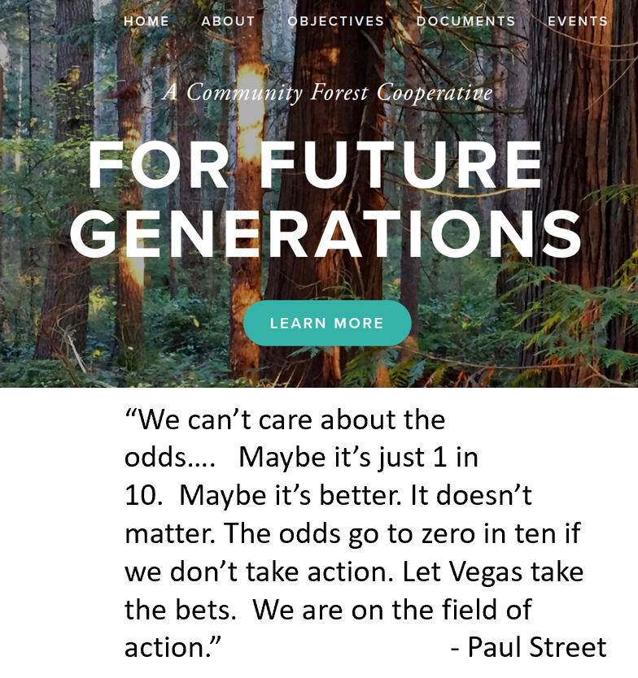
(Notes: The forest micro-climate may be important to local water supply and temperature stability. BC’s forest have been net carbon emitters for a decade. We can try to keep our forests as a carbon sink.)

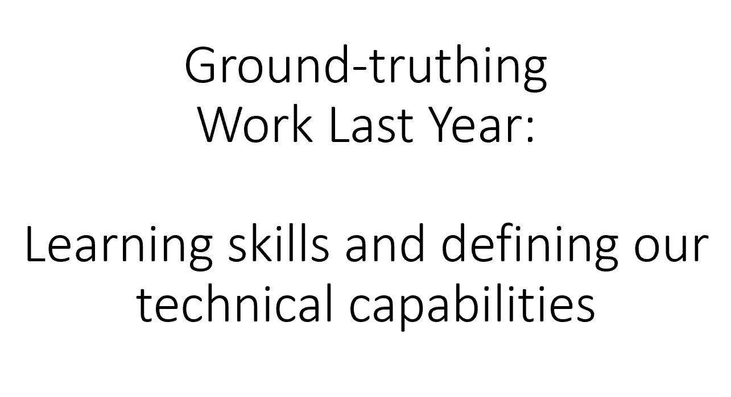
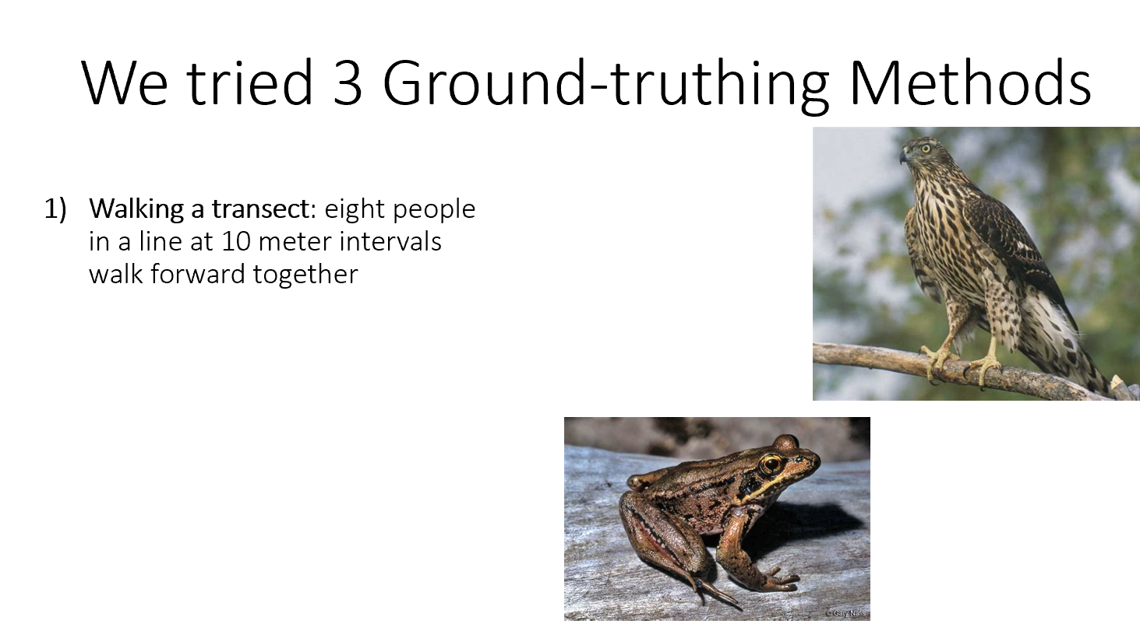
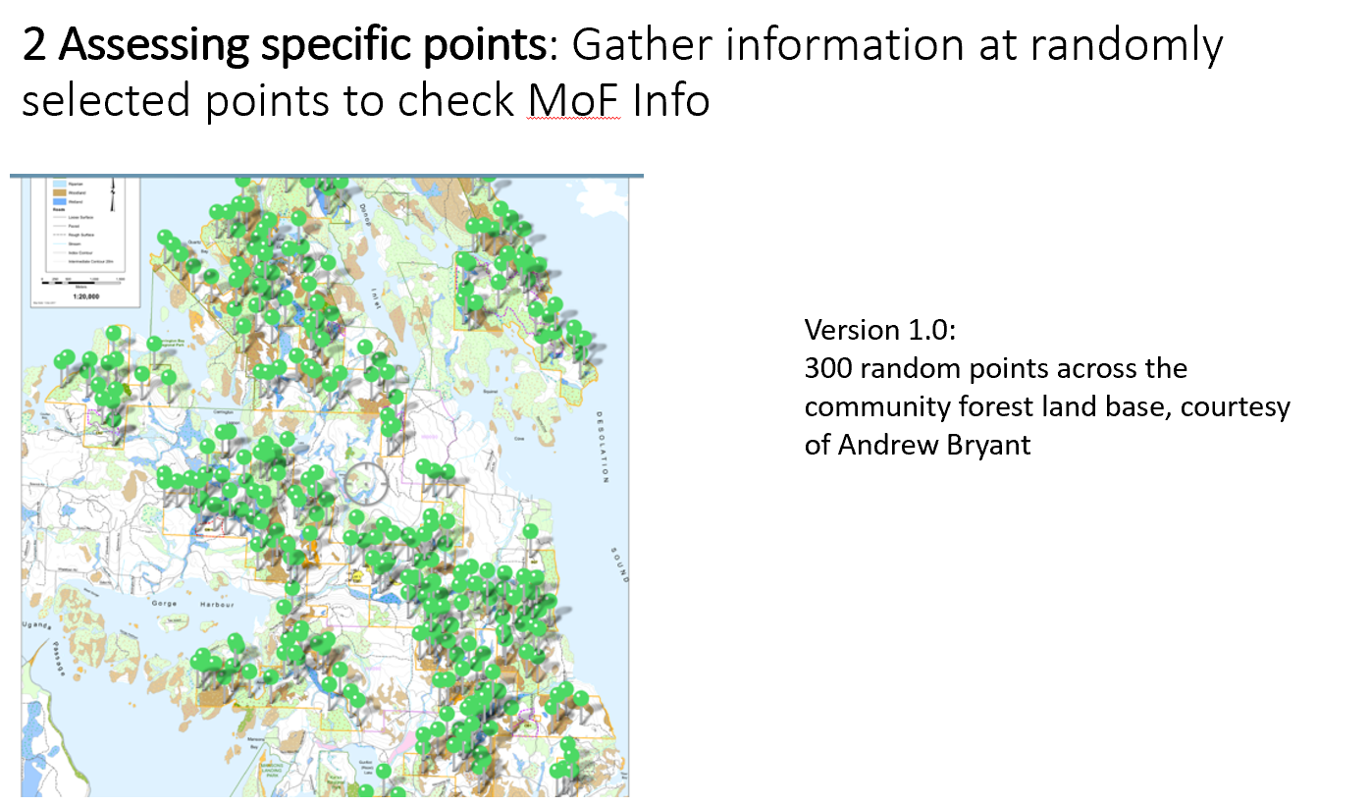
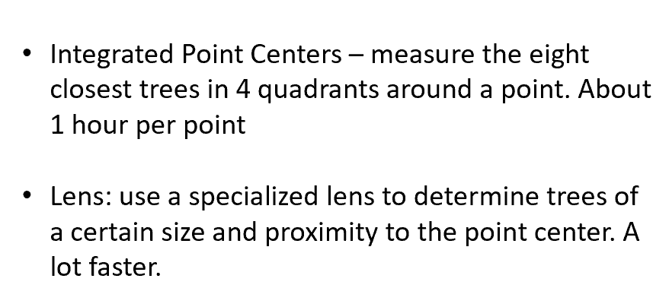
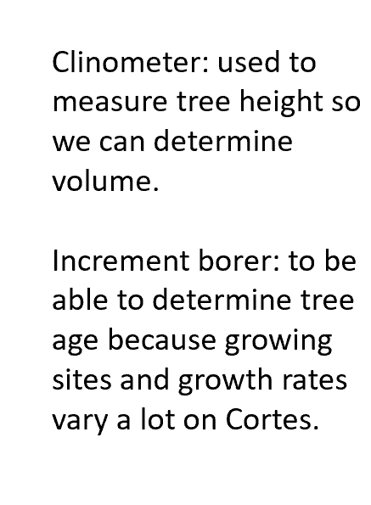
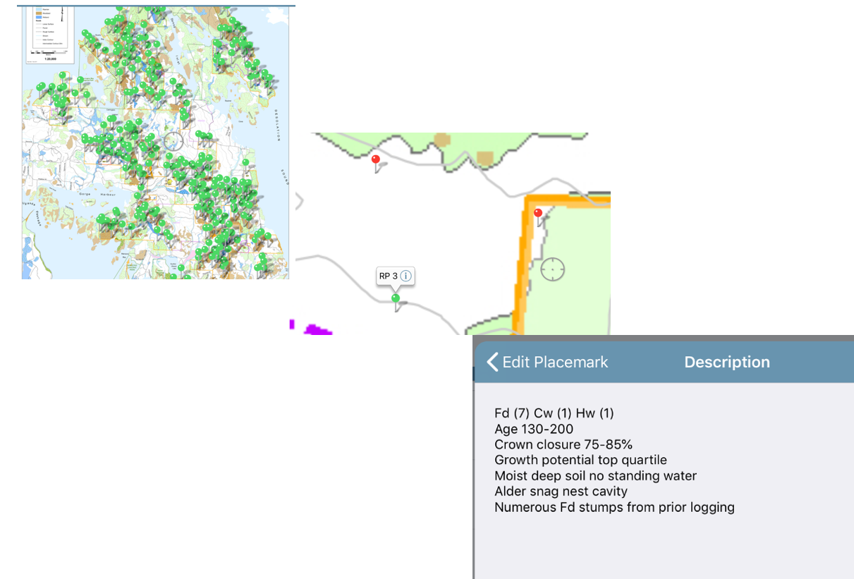

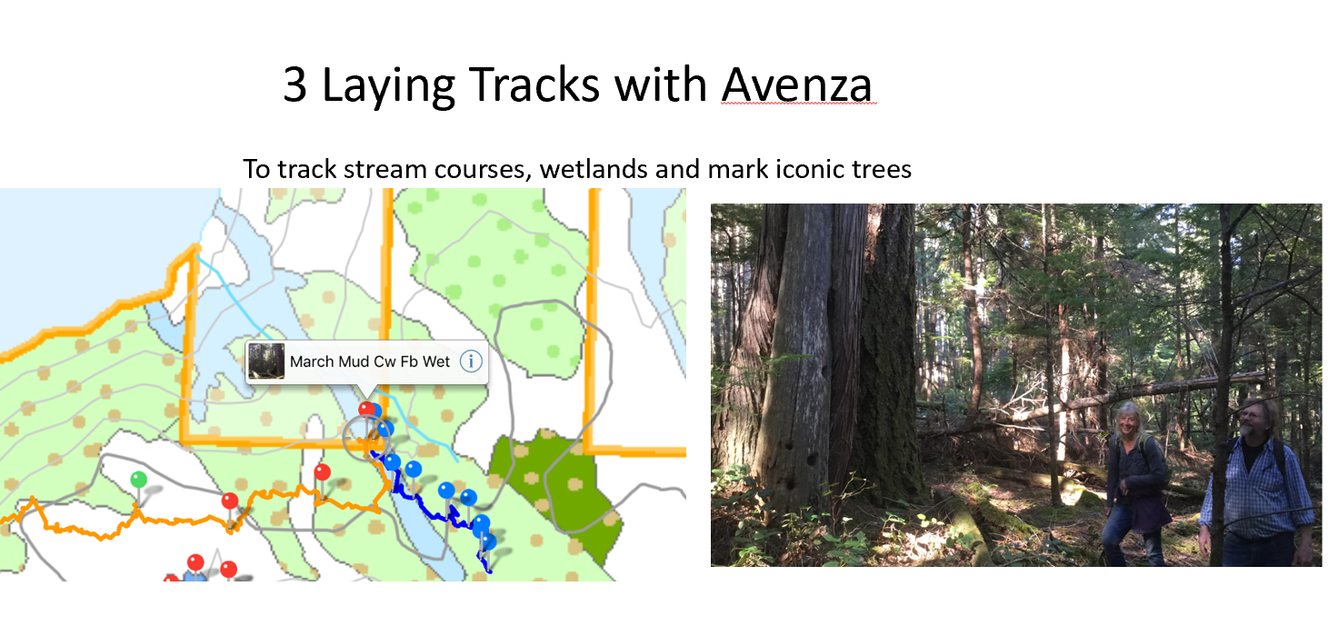
Put it all together and…..

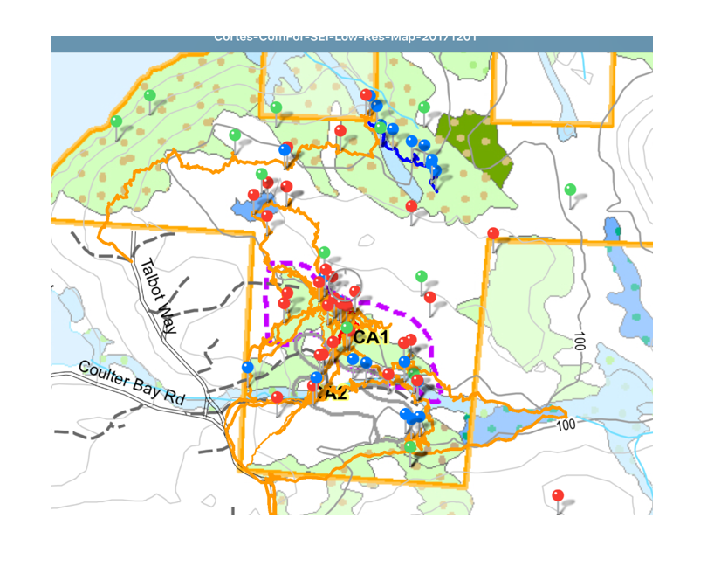
How an we put the information we gather into useful form?
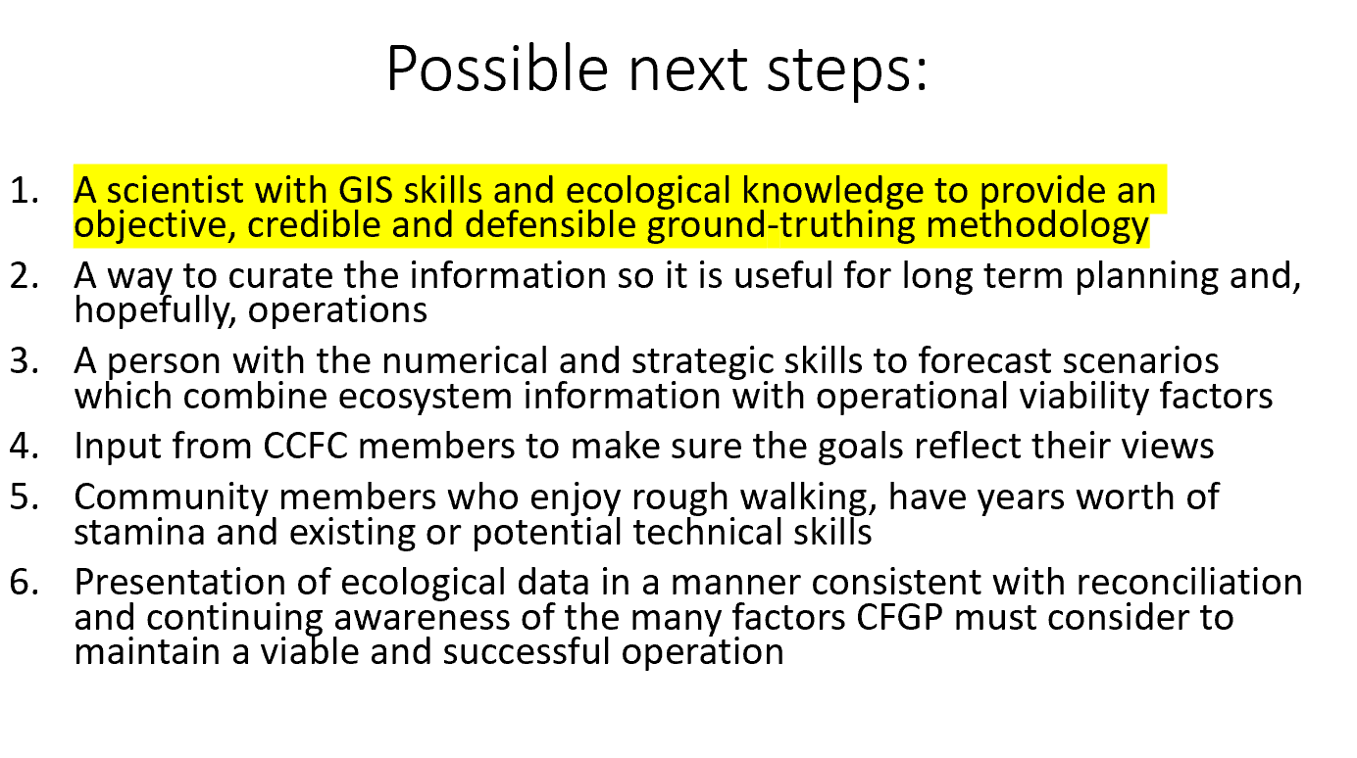
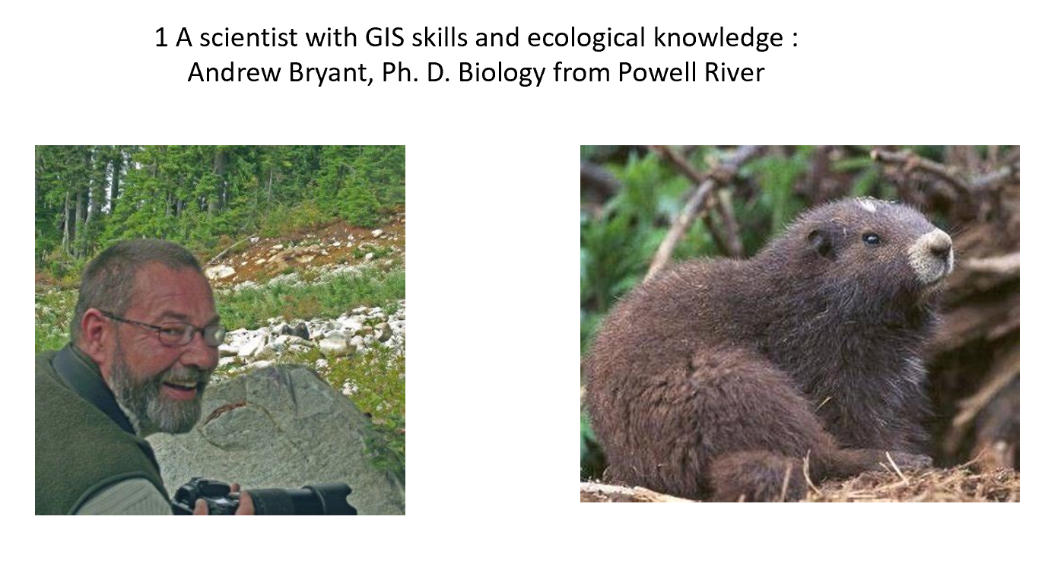
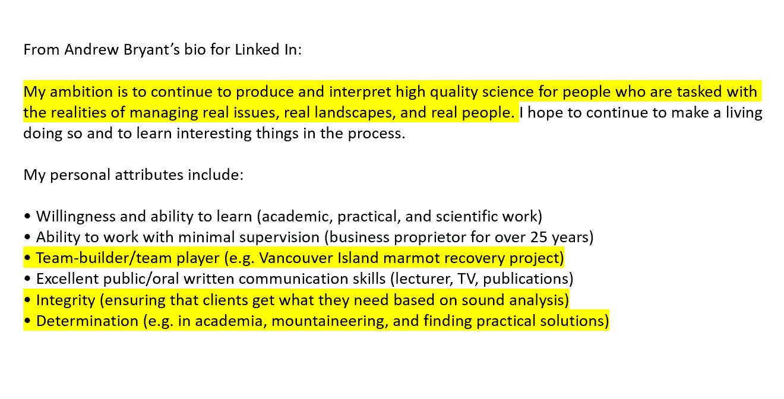

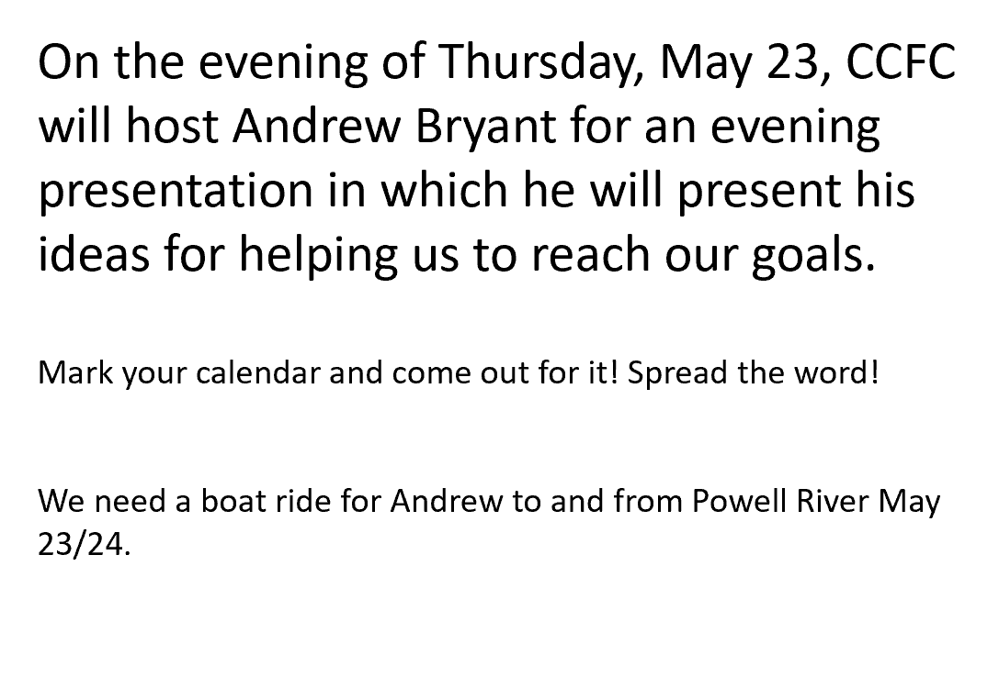
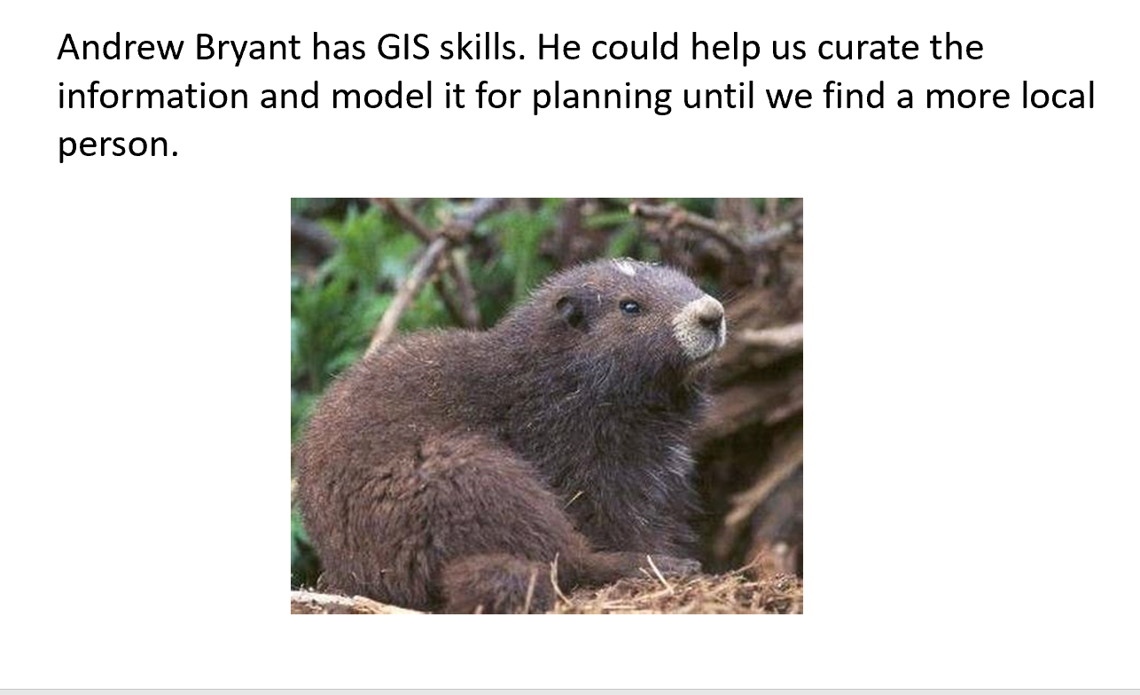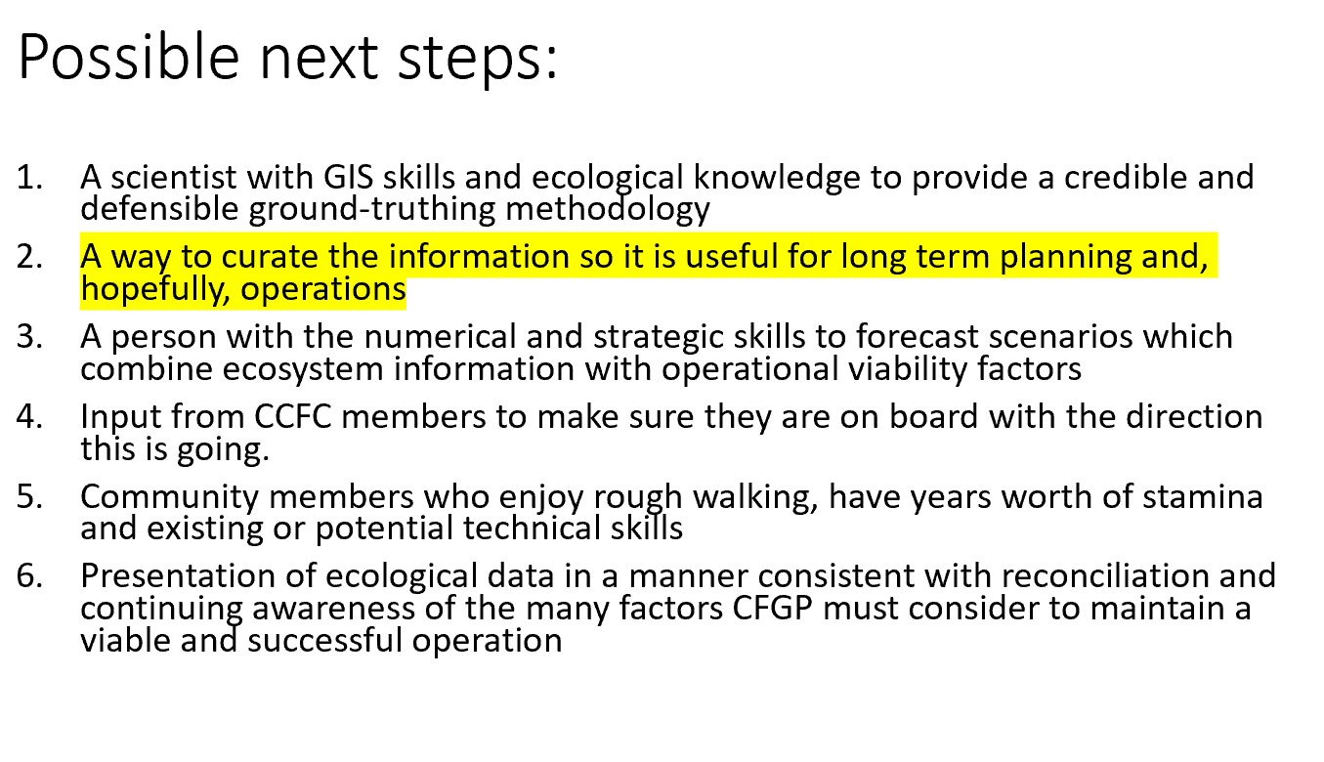

(Etc. There’s a few more slides not relevant to the mapping tasks)

